Quentin ANDRES

May 2021

Supervisor: Dr K. R. SALIN

Research proposal for the Master thesis <Proof of concept of a mRNA vaccine against Carp Edema Virus disease with low-cost experimental design>

**Table of content**

1. Introduction 4

2. A brief summary of relevant existing literature 4

3. Hypothesis 5

4. Research projects objectives 5

5. Methodology 6

6. Risks and Limitations 6

7. Summary and conclusions 6

8. Appendix 7

**Executive summary**

Fighting viral infection inducing mass mortality in fish is a hot-topic research in the aquaculture field in order to be able to sustain its intensification. This research project is about developing a vaccine against Carp Edema Virus for which there is currently no existing vaccine. I intend to develop a proof of concept for the production of a mRNA vaccine candidate using low-cost experimental design. This is a high-complexity and challenging research project I want to work on because I am passionate about biotechnology and cutting-edge technologies. To do so I will start with a bibliographic research on the methods and protocols that I will use during the experimentation. The first step in the realization of the vaccine consists in harvesting the virus and being able to recover the viral elements that will be the target of the vaccine. The mRNA vaccine in my project will be a messenger mimicking the infection from CEV in the Carps and will be synthesized by the means of common but also more advanced molecular biology techniques inside of bio-engineered bacteria as the transcription vector. The former step in the assessment of the transfection and translational efficiency of the candidate will be to quantify the activity of the messenger, in vitro, inside the Carp cells or inside of a related fish cell line via a reporter and by gene expression assay. During the latter stage of the experimentation, I will perform a challenge test in vivo on the carp fish, either in Koi (*Cyprinus rubrofuscus)* or in the common carp (*Cyprinus carpio*). The ultimate part of the project will be to monitor the results and communicate them to the community.

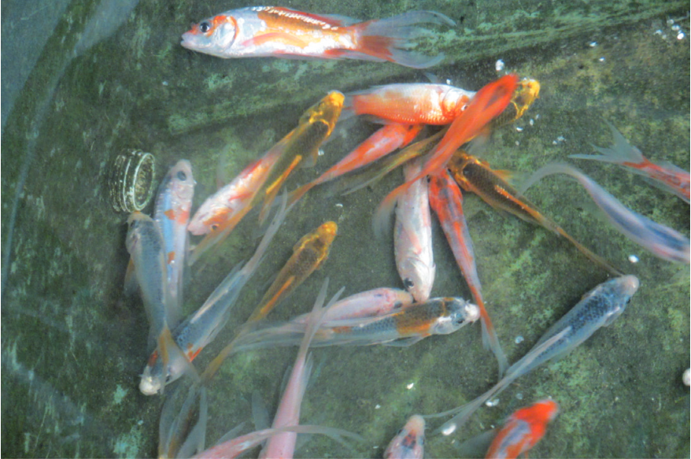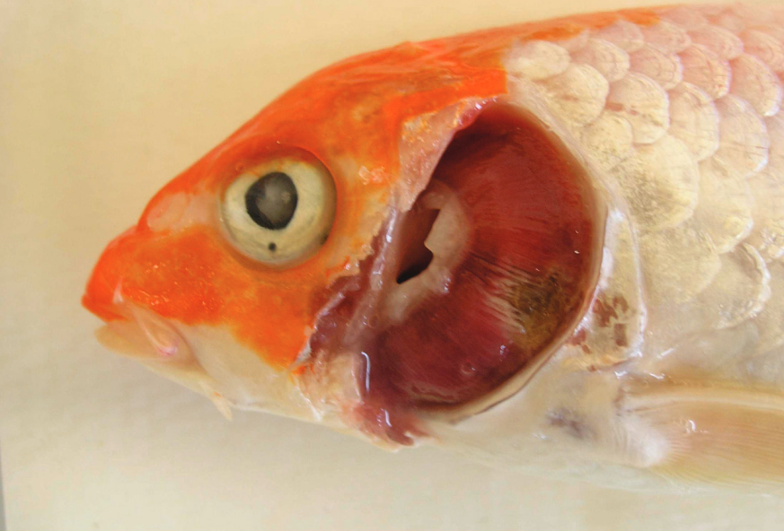

***(Left)*** *Koi with CEVD/KSD that presented with anorexia (loss of appetite), severe necrosis (cell death) of the gill tissue, and sunken eyes (koi had been frozen).*

***(Right)*** *A group of young-of-the-year koi displaying the typical KSD behavioural abnormality of extreme lethargy manifesting as fish lying motionless on their sides or bellies on the bottom of the tank.*

# Introduction

As a research project next year for the Master thesis, I would like to work on a proof of concept of a mRNA vaccine against the Carp Edema Virus disease (CEV), commonly called the Koi Sleepy Disease (KSD). This virus has been identified for the first time in Japan in 1970 and has spread world-wide with more recent outbreaks in 2015-2018 in East-European countries and has re-emerged in Thailand and China in 2020 inducing mass mortality of fish (*Pikulkaew, S.; Phatwan, K.; Banlunara, W.; Intanon, M.; Bernard, J.K. First Evidence of Carp Edema Virus Infection of Koi Cyprinus carpio in Chiang Mai Province, Thailand. Viruses 2020, 12, 1400.)*.

In order to sustain an intensified cyprinid aquaculture, many research units and private companies around the world are studying immune responses of fish to viral infections and are experimenting with vaccines development. There is currently no existing vaccine against the CEV. In vitro transcribed messenger ribonucleic acids use as a prophylaxis treatment for aqua cultured freshwater fish has just started.

I am inclined in moving forward in the field of molecular biology applied to aquaculture. Because of my background in molecular biology, microbiology and genomics, coupled to my knowledge about the carps, I think I have all the skills to achieve the proof of concept for a new vaccine candidate development against CEV. Since I know I will not have much funding for this research project, I would like to use as a specific objective for this research project the constraint of adopting a low-cost experimental design to achieve the vaccine production.

# A brief summary of relevant existing literature

Relevant literature on Carp Edema Virus Disease (CEVD) / Koi Sleepy Disease (KSD)

* *Shohreh Hesami, Pedro Viadanna et al.* [*https://edis.ifas.ufl.edu/pdf/FA/FA18900.pdf*](https://edis.ifas.ufl.edu/pdf/FA/FA18900.pdf)
* *Amita, K., M. Oe, H. Matoyama, N. Yamagushi, and H. Fukuda. 2002. "A survey of Koi herpes virus and carp edema virus in colorcarp cultured in Niigata Prefecture, Japan." Fish. Pathol. 37:197–8.*
* *Haenen, O., K. Way, D. Stone, and M. Engelsma. 2013. "Koi Sleepy Disease found for the first time in koi carps in the Netherlands." [in Dutch]. Tijdschr. Diergeneeskd. 5:27–29.*
* *Lewisch, E., B. Gorgoglione, K. Way, and M. El-Matbouli. 2015. "Carp edema virus/koi sleepy disease: An emerging disease in central-east Europe." Transbound Emerg Dis. 62:6–12.*

Relevant literature on mRNA vaccines

* Pardi, N., Hogan, M., Porter, F. et al. mRNA vaccines — a new era in vaccinology. Nat Rev Drug Discov 17, 261–279 (2018). <https://doi.org/10.1038/nrd.2017.243>
* Gómez-Aguado, I.; Rodríguez-Castejón, J.; Vicente-Pascual, M.; Rodríguez-Gascón, A.; Solinís, M.Á.; del Pozo-Rodríguez, A. Nanomedicines to Deliver mRNA: State of the Art and Future Perspectives. *Nanomaterials* **2020**, *10*, 364. <https://doi.org/10.3390/nano10020364>

Relevant literature on low-cost experimental design

* <https://pipettejockey.com/2019/11/22/teda-cloning-cheap-easy-gibson-alternative/>
* <https://pipettejockey.com/2020/02/05/t4-dna-ligase-plasmid-brought-to-you-by-chemically-incompetent/>
* <https://barricklab.org/twiki/bin/view/Lab/ProtocolList>

# Hypothesis

Even if literature is missing on CEV vaccine development, a lot of literature on IVT technologies for both Cancer and Infectious diseases are available online. The Tilapia lake virus (TiLV) but also the Influenza virus are two negative strand RNA viruses, and similarly to that of the CEV, some of the methods and protocols for the IVT but also the dynamics in the host/fish immunity response are likely to be the same.

Assumption that CEV and TiLV have a close molecular physiology and replicative mechanism can benefit me in the project because the literature of the latter is available.

My second assumption is the feasibility of the vaccine production using low-cost experimental design. Alternative techniques are widely used to cut production costs and there are tons of literature on those methods.   
It will always be possible to monitor the evolution of the process of production of the mRNA design. A framework will be followed according to the literature and to the outcomes of each steps.

# Research projects objectives

The primary objective of this research project is to demonstrate that using simple molecular biology low-cost techniques, it is possible to recover some key genes or the full genome of the CEV via an infected sample, then to later clone those fully recovered sequences into a bioengineered bacterium. By the means of vector design via bioinformatics, the mRNA vaccine parts free of the candidate CEV gene and containing 2 cleaving/restriction enzyme sites will be designed.

The second objective is to set up a bacterial transcription platform holding the appropriate modifications in its plasmid genome (=The mRNA vaccine parts in the correct orientation relative to the promoter). This will allow me to easily and efficiently clone/insert any protein coding sequence of CEV recovered previously.

The more specific objective of this research project is to be able to produce the vaccine using low-cost experimental design, which will be more complex and challenging than out-sourcing the sequencing to a biotech company that will charge a lot of money, I don’t have, for de novo DNA synthesis. Many alternative techniques using low-cost PCR operations will be favoured.

The last and ultimate objective is to deliver an efficacy-indicating study of the fish survival rate.

If I have time, I wish to monitor the viral infection in fish using a staining reporter such as Luciferase in vivo or using a fluorescent modified reporter Carp Edema Virus.

# Methodology

I expected to be able to set-up of a collaboration scheme with Chiang Mai research unit that has recently worked on the CEV in the last year. I would like them to provide me with virus sample, gene sequence, results of virus electrophoresis after a purification and digestion with restriction enzyme, and other valuable information.

I have broken down the project work in several phases.

* Literature research/ Bibliographic research.
* Bioinformatics for the vector design and mRNA design.
* Culture and creation of the expression system.
* Final vaccine synthesis.
* IVT in vitro.
* IVT in vivo.
* Challenge tests
* Communication of the results.

# Risks and Limitations

I would need access to a lab facility to do the experiments and setting up the small bacterial vaccine production system, while PCR and all the activities relative to Carp culture, water analysis and preparation of the challenge test can be one at AIT. I need to access a simple microbiology laboratory, either in another department of the AIT or in a nearby university such as Thammasat Rangsit.

The time frame to do the experiments and conduct the research is feasible and seems reasonable to me. Even if the reactants or the funding is obtained late, the whole project will be able to be done is less than 6 months from the start of the hands-on work. Using iterative processes, I expect to get a conclusive vaccine efficacy in the Carp by the end of the project.

Cost of raw materials might be a limitation to the iterative process (test of several candidates/ failure in challenge tests?). Culture of the bacteria and harvesting of virus might also not be simple but the risks will be mitigated with a good management.

# Summary and conclusions

I know how complex and challenging this research project is. I have the scientific background and the support needed for this project. I have acquired during my bachelor’s in molecular biology and genomics the broad knowledge and I with it, I have also my experience of my first year of the ARRM master. All will contribute to the success of this project. I am highly motivated to achieve the research project objectives and I will make the demonstration that creating a CEV vaccine specifically with low-cost experimental designs can be successful and hope to inspire others to pursue in the fight against fish infectious disease using prophylaxis.

I have a clear idea of the methodology to be set-up both on the bioinformatic part to design CEV vaccine candidates and on the biomolecular experiments to produce the vaccine. I now must focus on having access to a lab facility and some funds to buy some raw materials for the vaccine production. That are the main major issues at this stage I need to tackle.

# Appendix

***Figure 1****. Illustration of steps involved in a possible route for the elaboration of a CEV mRNA candidate vaccine. The figures give a general workflow to the master research project.*

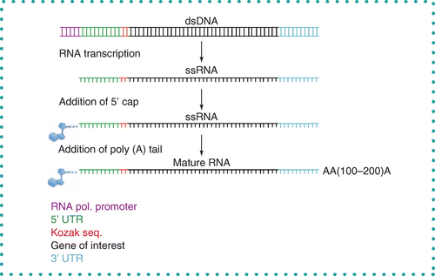

***Figure 2****. Illustration of steps involved in the production of a CEV mature mRNA candidate vaccine.*

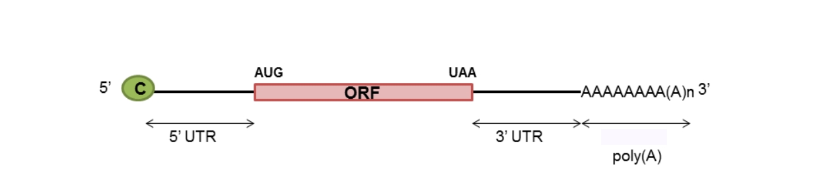

***Figure 3.*** *Schema of mature RNA: The green C is the Cap. The 5’UTR is upstream of the AUG codon, the 3’ UTR is downstream of the UAA codon but upstream of the poly(A) tail at the 3’ side of the mRNA sequence.*

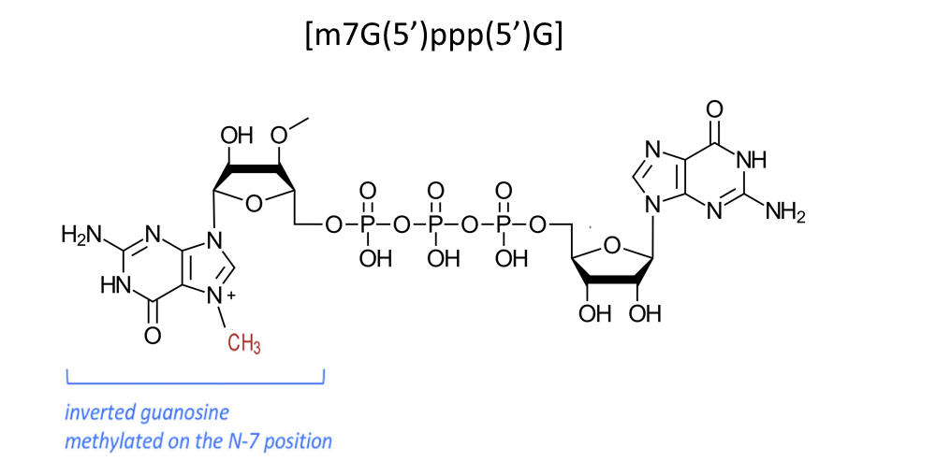

***Figure 4.*** *The 5’Cap structure analog consisting of – m7G(5’)ppp(5’)G –*

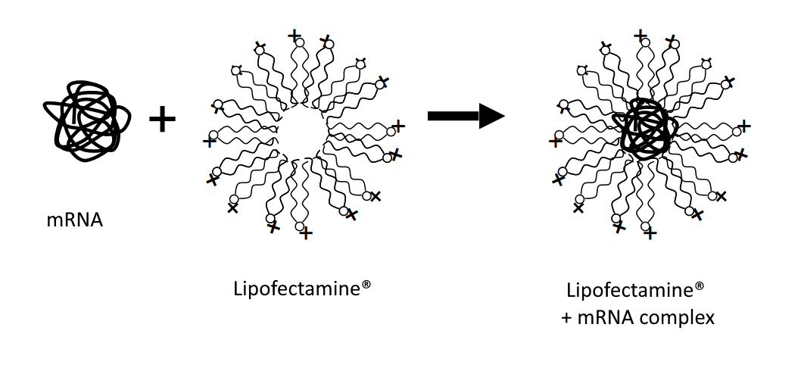

***Figure 5.*** *The mRNA packing in the lipid nanocarrier (LNP) vector.* *In the experiment, we have the choice to use* ***Lipofectamine 3000*** *for the transfection, which is a combination of* ***DOSMA*** *(the polycationic lipid 2,3-dioleyloxy-N-[2(sperminecarboxamido)ethyl]-N,N-dimethyl-1-propanaminium trifluoroacetate) and of* ***DOPE*** *(dioleoylphosphatidylethanolamine) It is probably the most expensive reagent that we cannot replace, the cost is 600$ for 30 injections (30 carps).*

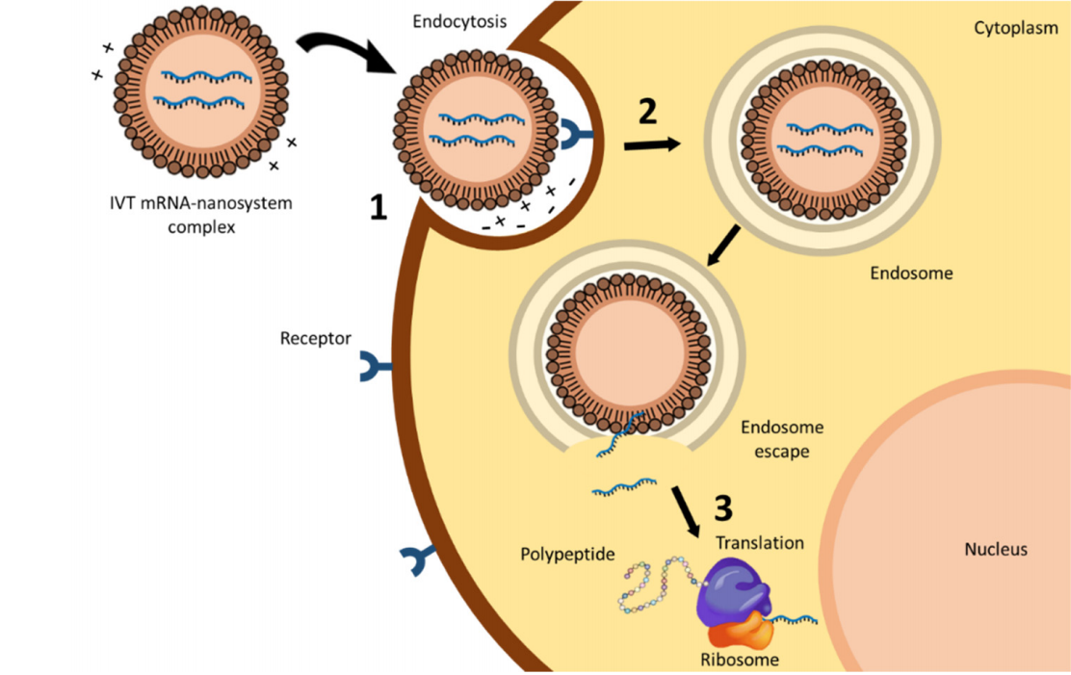

***Figure 6.*** *Intracellular barriers for in vitro transcribed (IVT) mRNA delivery: (1) Interaction between the delivery system and cell membrane, (2) endocytosis, and (3) endosomal escape and release of the mRNA to start the translation process.*

*Credits: G.Itziar, J.Rodr, M.Vicente-pascual et al,* [*https://doi.org/10.3390/nano10020364*](https://doi.org/10.3390/nano10020364)

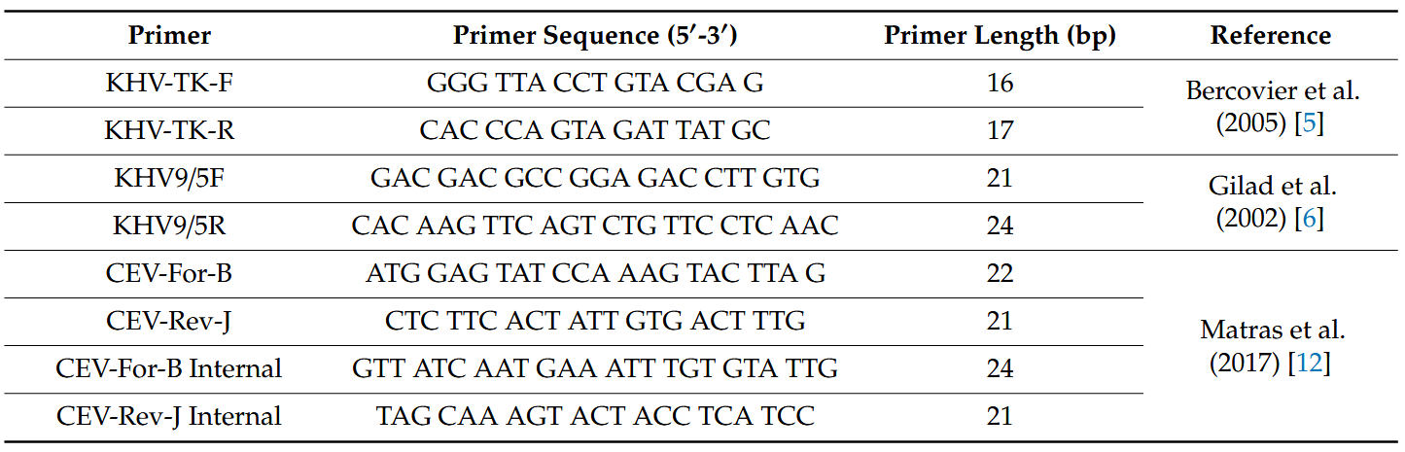

***Figure 7.*** *List of oligonucleotide primers for the detection and amplification of carp viruses.*

| ***Table 1.*** *Cost and time estimate for the CEV mRNA master thesis research project.* | | | | | | |
| --- | --- | --- | --- | --- | --- | --- |
|  | **Low-cost experimental designs** | **Vendor** | **Reagent costs ($)** | **Cost for 1 ($)** | **Hands-on time (h)** | **Total time (h)** | |
| Day 1 | Virus recovery and harvesting | Chiang Mai | 75.00–100 | 150.00 | 1 | 2 weeks |
| Day 1 | Virus digestion + retro transcription | TBD | 5 | - | - | - |
| Day 1 | PCR overlap / Gibson assembly | Ourselves | 5-15/u | - | - | - |
| Day 1 | Purchase bacterial expression vector + culture | NEB | 75.00-100/clone | 100.00 | 1 | 48 |
| Day 2 | Digest vector and add restriction sites with restriction cloning | NEB | 5-10/u | 0.10 | 0.5 | 1 |
| Day 2 | Run on gel | Sigma | 1.97/g | 1.97 | 0.5 | 1 |
| Day 2 | Gel extraction + cleanup | Qiagen | 2.3/rxn | 2.30 | 3 | 3 |
| Day 3 | Ligation of viral cDNA to plasmid vector | Thermo Fisher | 1.18/rxn | 1.18 | 0.5 | 0.5 |
| Day 3 | Transformation in E.coli | Thermo Fisher | 19.92/rxn | 19.92 | 1 | 1 |
| Day 3 | Out grow | Media | Negligible | - | 0.5 | 18 |
| Day 3 | Plating | Media | 2/plate | 10.00 | 1 | 2 |
| Day 4 | Colony screening | Taq | 0.5/U | 10.00 | 1 | 18 |
| Day 4 | Run on gel | Sigma | 1.97/g | 3.94 | 0.5 | 2 |
| Day 4 | Pick PCR positives, start cultures | Media | Negligible | - | 1 | 18 |
| Day 5 | Make mini preps | Qiagen | 1.81/rxn | 23.60 | 4 | 3 |
| Day 5 | Digest with RE | NEB | 0.05/U | 1.00 | 0.5 | 1 |
| Day 5 | Run on gel | Sigma | 1.97/g | 3.94 | 1 | 2 |
| Day 6 | Send clone for sequencing validation | Genewiz | 4/rxn | 20.00 | 1 | 18 |
| Day 7 | Start cultures for Maxi preps. | Media | negligible | - | 0.5 | 18 |
| Day 8 | Prepare DNA for transfections | Qiagen maxi | 24.5/rxn | 24.50 | 4 | 18 |
| Day 10 | mRNA purification | mMachine | TBD | - | - | - |
| Day 10 | mRNA Capping | TBD | TBD | - | - | - |
| Day 10 | Transfection LNP | TBD | 600 $ for 30 fish | - | - | - |
|  | Totals |  | 400-500-1200 | 372.45 | 22.5 | 172.5 |

IDT: Integrated DNA technology; NEB: New England Biolabs